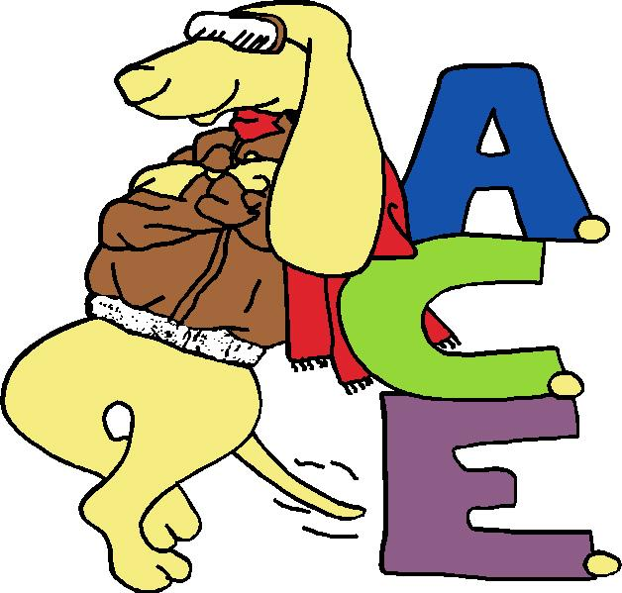

Agility Club of Evansville
Class Schedule
Summer 2026

For more information contact the training directors:
Ann Powell & Victoria Wright - train@agilityclubofevansville.com
Training tools needed: Flat buckle collar, leash, water and dish, small, soft, food treats and/or favorite toy, crate or safe and secure place for your dog if you have more than one dog in classes. Remember to wear comfortable shoes and clothing.. PLEASE NO PRONG, E-COLLAR OR CHOKE CHAIN.
ACE strongly suggests your dog complete a beginner obedience class to maximize your fun in our agility classes and workshops.
Notification for canceled class will be given 1-5 hours prior to class in case of bad weather or instructor emergency. Please include a number where you can be reached on your registration.
For classes dogs must provide proof of distemper/parvo combo and current rabies vaccine. Kennel cough vaccine is HIGHLY recommended. For each class session, a copy of vaccine records must be sent with a signed registration form.
Please mail registration form, vaccine records, with check payable to ACE to: Jennifer Henderson, ACE Treasurer, 3213 Washington Ave., Evansville, IN 47714.
OR email to jhenderson@euea.org & train@agilityclubofevansville.com and paythrough PayPal - train@agilityclubofevansville.com. When sending payment please add your first and last name, class name, and dog's name to the description. An additional fee will be added for PAYPAL registrations listed below.
Name________________________________________ Day Phone ____________________
Eve. Phone________________ Address_________________________________ City______________
St_______ Zip___________ E-mail_______________________________________
Dog’s name______________________________________________ Dog’s age________
Breed___________________________________
(Please check the class)
Location: 7405 Wassmer Rd Poseyville  Starting June 29th, July 6th, 13th, 20th, 27th, Aug 3rd  Monday  Instructors: Victoria Wright  Asst. Donna Johnston | Agility Classes- 60min - $75 - 6 weeks PAYPAL PRICE- $78  - 6:30pm Intro to Obstacles
Location: 7405 Wassmer Rd Poseyville  Starting June 29th, July 6th, 13th, 20th, 27th, Aug 3rd  Monday  Instructor: Victoria Wright  Asst. Donna Johnston | Agility Classes- 60min - $75 – 6 weeks PAYPAL PRICE- $78  - 7:45 pm Agility 2 - Contacts
Location: Rotating location in Evansville  Starting May 27th, June 3rd, 10th, 24th, July 1st, 8th  Wednesday  Instructor: Jamie Carr | Scentwork- 30 min - $ 37.50 - 6 weeks - PAYPAL PRICE- $39.50  - 5:30 pm Introduction to Scentwork
Location: Rotating location in Evansville  Starting May 27th, June 3rd, 10th, 24th, July 1st, 8th  Wednesday  Instructor: Jamie Carr | Scentwork - 60 min - $75 - 6 weeks - PAYPAL PRICE - $78  - 6:00 pm Intermediate- Step Up Scentwork
In consideration of my participation in the training programs of ACE, their agents, and trainer I the undersigned , waive, release, and discharge any and all claims for damages, for death, personal injury, or property damage which I may have or which may subsequently accrue to me or my pet as a result of my participation in these programs or future programs.
It is further understood and agreed that this waiver, release, agreement and assumption of risk is to be binding on my heirs and assigns.
SIGNATURE: __________________________ Date: ___________ (in case of minor, a parent or legal guardian must sign)

